You can maintain data of multiple pages using session.
Making a calculator:
- You can create a html form inside jsp to make the page and take value as inputs.
- Let’s say the form action is mentioned as = ‘add’. SO, upon clicking the submit button in the form it will redirect us to /add page.
- So, we need to create another page using jsp where we will provide the final value and we need to map that ‘/add’ to a another controller class.
- We are taking the inputs from the client , so we to need take the inputs using HttpRequest.
- But main problem comes how will we return the result amount from a differenet page. That’s where session comes in, session can store the value and we can call that value from whichever file we want. 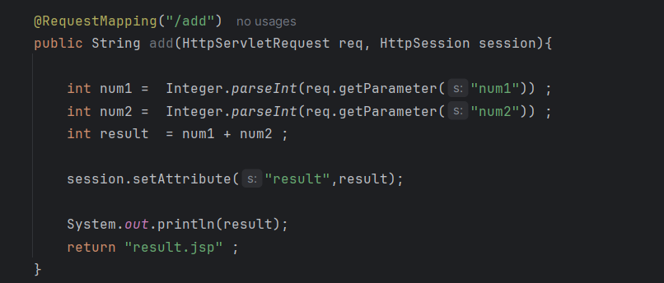
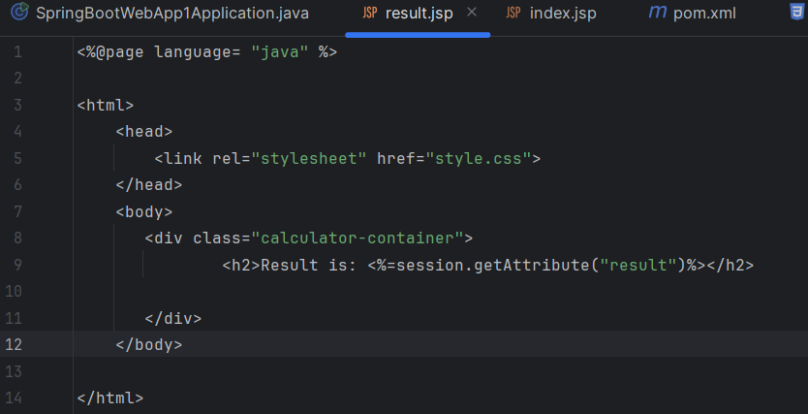
We can write it like it that or we can just simply use ${result} to return the value from result.jsp
<h2>Result is: ${result}</h2>

